SPRAYMANUK HVLP PRESSURE CUP

SPUK060
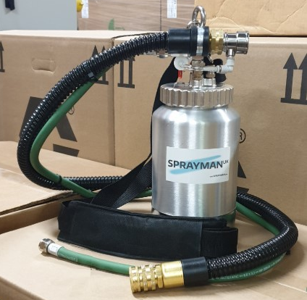
Thank you for purchasing our SpraymanUK HVLP Pressure cup. We hope it will give you many years of service.
If you should you have any service-related problems with the pressure cup or fittings,
then please contact us on 01543 496289 and select the SERVICE option.

Pressure Cup Specification
Max Tank Pressure: 50 PSI / 3.4 Bar
Tank Max Working Pressure: 40 PSI / 2.7 Bar
Fluid Outlet: 3/8” BSP
Weight: 1.0 kg
Tank Capacity: 2 Litre

For a detailed set up assembly instruction video, then please go to www.youtube.com and search for our YouTube channel Sprayman UK. The video title is:
Setting up our Sprayman UK Pressure Cup for HVLP Turbine Systems.

Alternatively, you can type in the following URL into your web browser:
https://youtu.be/okPJTRENpqE

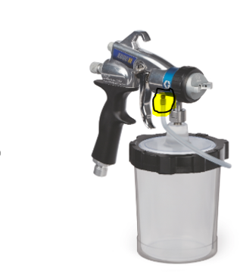
Supplied with this kit are two rubber plugs, with one serving as a spare.
These plugs are designed to seal the air outlet on your Graco HVLP EDGE II Plus spray gun (specifically the Flexliner Type), which is typically used to pressurise the pressure cup or Flex-liner cup. However, this pressurisation is no longer necessary when using the SpraymanUK HVLP Pressure Cup System.
You can see this indicated in the highlighted area on the accompanying photograph for clarification.

Replacement Parts
Parts can be ordered online at www.sprayman.co.uk/product_catergory/parts/
